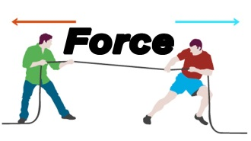**Year 7 physics revision questions**

1. **Write the definition ( meaning) of the following terms:**
2. Force:---------------------------------------------------------------------------------------------------------------
3. Gravity:-------------------------------------------------------------------------------------------------------------
4. Balanced forces:--------------------------------------------------------------------------------------------------
5. Unbalanced forces:----------------------------------------------------------------------------------------------
6. Contact forces:---------------------------------------------------------------------------------------------------
7. Non-contact forces:---------------------------------------------------------------------------------------------
8. Electrostatic force:-----------------------------------------------------------------------------------------------------------------------------------------------------------------------------------------------------------------------------
9. Friction:------------------------------------------------------------------------------------------------------------------------------------------------------------------------------------------------------------------------------------------
10. Mass:-------------------------------------------------------------------------------------------------------------------
11. Weight:----------------------------------------------------------------------------------------------------------------
12. **The rules of electrostatic forces are:**
13. Unlike charges------------------------------------.
14. Charged objects ---------------------------------------------------------------.
15. Like charges------------------------.
16. **Examples of contact and non-contact forces.**

------------------------------------------------------------------------------------------------------------------------------------------------------------------------------------------------------------------------------------------------------------------------------------------------------------------------------------------------------------------------------------------------

1. **List some of the ways to reduce friction.**

------------------------------------------------------------------------------------------------------------------------------------------------------------------------------------------------------------------------------------------------------------------------------------------------------------------------------------------------------------------------------------------------------------------------------------------------------------------------------------------------------------------------------------------------------------------------------------------------------------------------------------------------------------------------------------------------------------------------------------------------------------------------------------------------

1. **What unit of measurement is used when measuring force and what is the symbol?**

--------------------------------------------------------------------------------------------------------------------------------

1. Complete the following sentences:
2. A north pole and a north pole--------------------------
3. A south pole and a south pole ----------------------------
4. 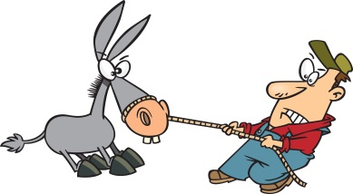A north pole and a south pole ----------------------------